Schoology Cheat Sheet

***Students need to use the web browser instead of the app to get on Schoology***
- Parents log in to schoology.com
- Students log in to kanawha.schoology.com

How To Find Assignments
- Every assignment for each course can be found in three different places:
  - In each course under “Materials” (that should be what you see first, but if not, “Materials” is on the left-hand side)
  - On the calendar on your child’s home page
  - Graded assignments will show up in the gradebook, so you can also click on the Grades icon to find new assignments. How to check grades and find the grades icon will be later on this cheat sheet.
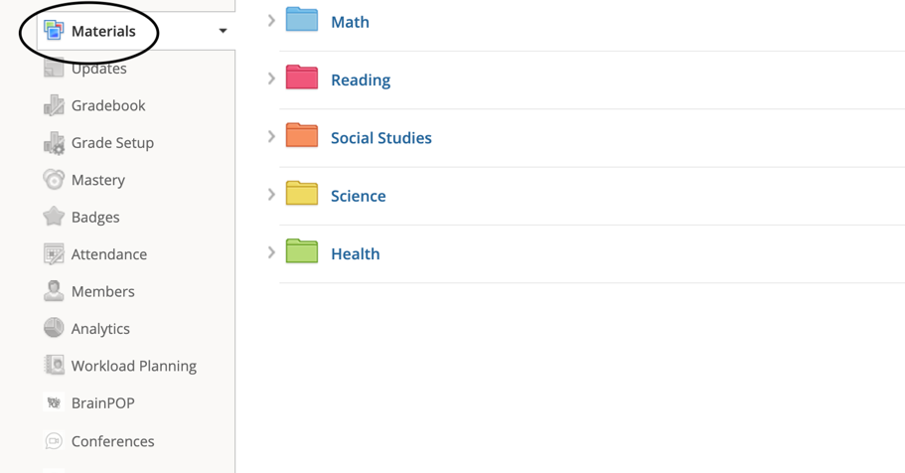
How to Submit Assignments
- There are two types of assignments:
  - Teachers can create assignments that will be completed in Schoology, such as quizzes and tests.
  - All assignments will usually be in a folder on the course page.
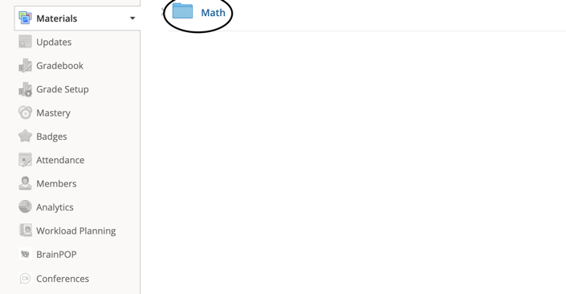
  - These assignments will have a green puzzle piece beside the assignment name.
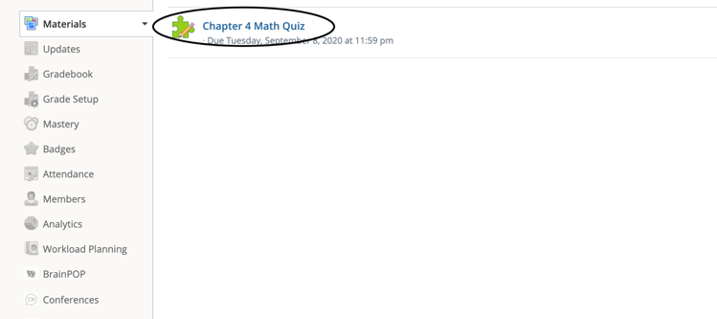
  - Teachers can also attach files, like PDF files, that need to be worked on in other programs.

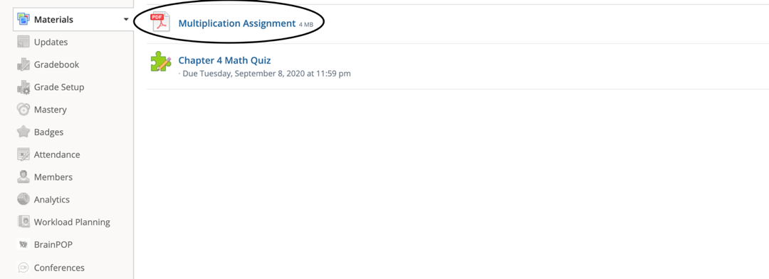
- For Schoology created assignments (the puzzle piece assignments), the students will complete them on Schoology and click “Submit” at the bottom of the page when they are done.
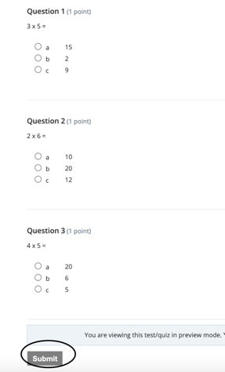

- To complete an assignment that needs to be done in another program (like a PDF file), click on the assignment and then click on the Download icon on the top-right of the assignment.
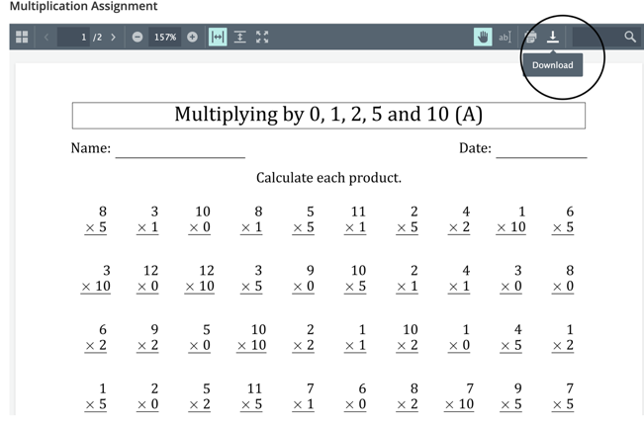
- After the assignment is downloaded, you can open the file by clicking on the blue folder icon at the bottom of the home screen on your child’s iPad.
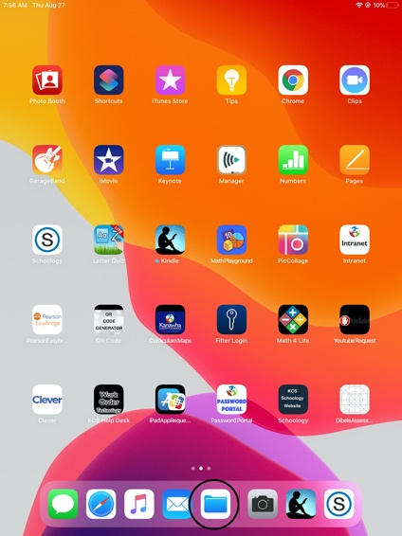
- When you open the downloaded file, you can now use the Markup icon in the top right-hand corner to write on the assignment.
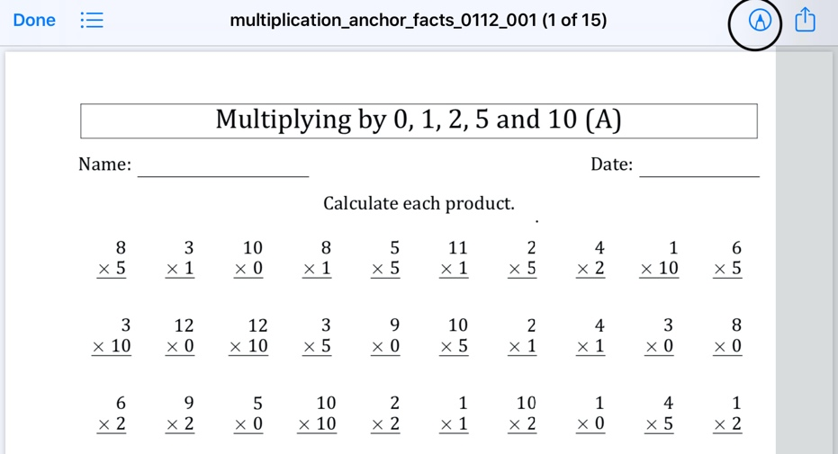
- After the student finishes the assignment, they will click on the share button in the top right-hand corner (the box with the arrow pointing up) and scroll across to find Schoology. Click on Copy to Schoology.
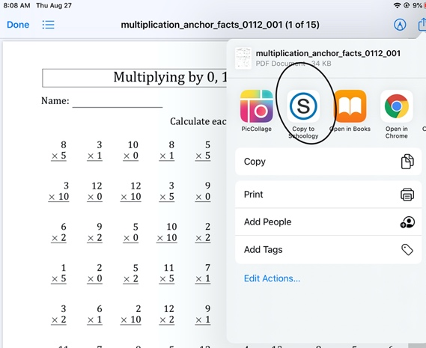
- It will take the assignment to Schoology. Then pick Submit to Assignment.
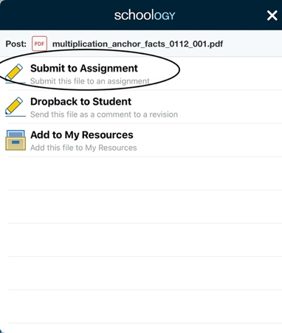
- Click on the correct course/subject for the assignment. So if it is a math assignment, click on the math course.
- Finally, click on the correct assignment name to turn it in.

How To Check Grades
- Click on the arrow in the upper-right corner beside your name and select your child’s name to view their account activity.
- To check your child’s grades, click on Grades at the top of the screen (number 5 on the picture).
- Here you can review your child’s grades for all courses/subjects.
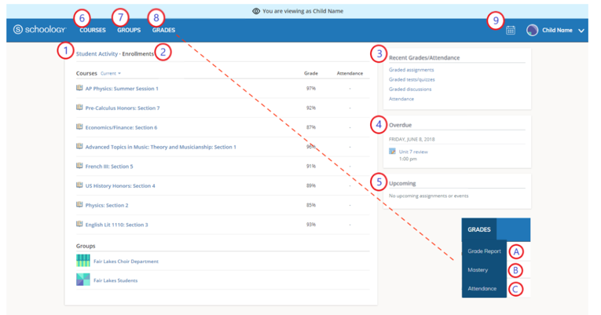

Notifications
- You can turn on Notifications to receive notifications about grades, assignments, and other important information that you would like to receive.
- To turn on Notifications, click on the arrow in the upper-right corner of Schoology beside your name.
- Then click on Settings.
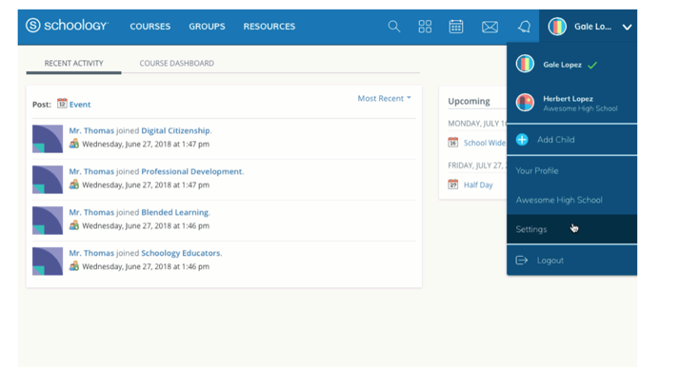
- Click on the Notifications tab at top of the page.
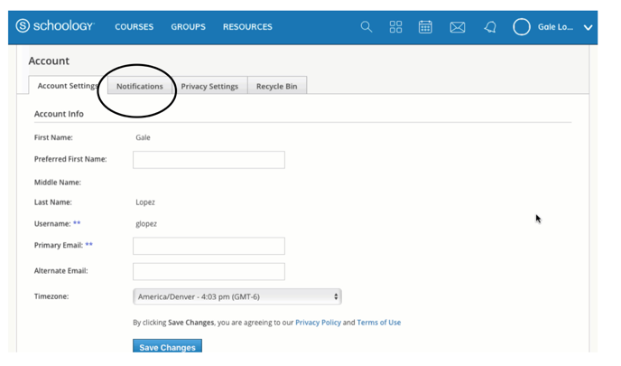
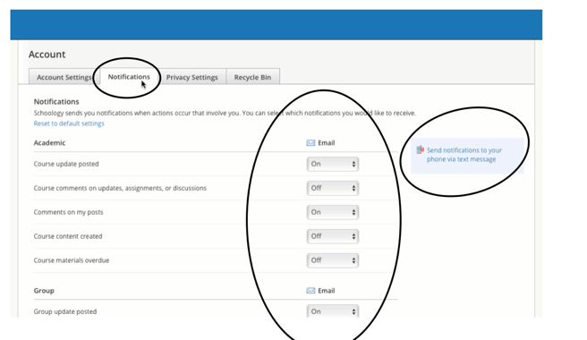
- Here you can turn on email notifications to receive notifications about grades, assignments, and other important information that you would like to receive.
- You can also turn on text message notifications.

Messaging the Teacher
- You can message the teacher on Schoology about any concerns or questions.
- The Messages icon (the envelope) is in the top right-hand corner beside your name.
- When you have a new message, the Messages icon will display a new number.
- New messages will have a blue dot beside them.
- To message the teacher about any concerns or questions, click the + New Message button. Fill out the form and click Send to complete.
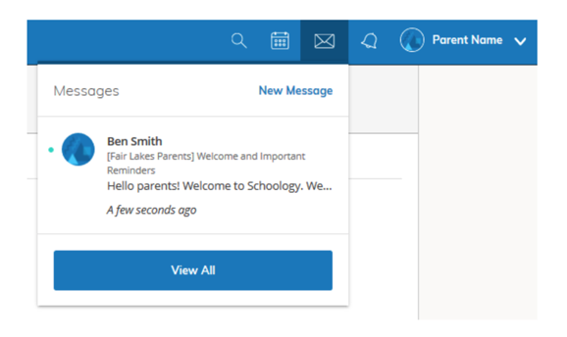

Upcoming
- The Upcoming area shows a list of upcoming events and due dates for graded items from your child’s courses/subjects.
- If you want to know more details about the item, click on the item name from the list.
- The Upcoming area can be found on the Recent Activity page.
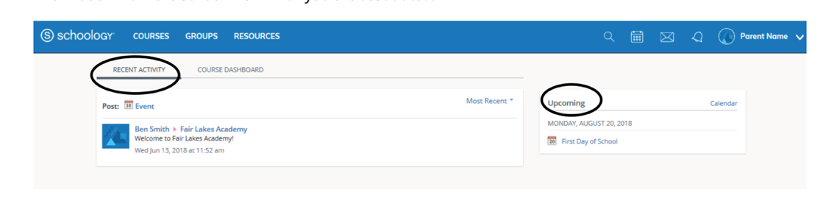

Calendar
- Another way to see events and assignments scheduled for your child is to click on the Calendar icon.
- This will show you all of the events and assignments that have been scheduled at a glance for each month.
- The Calendar icon is to the left of the parent name.

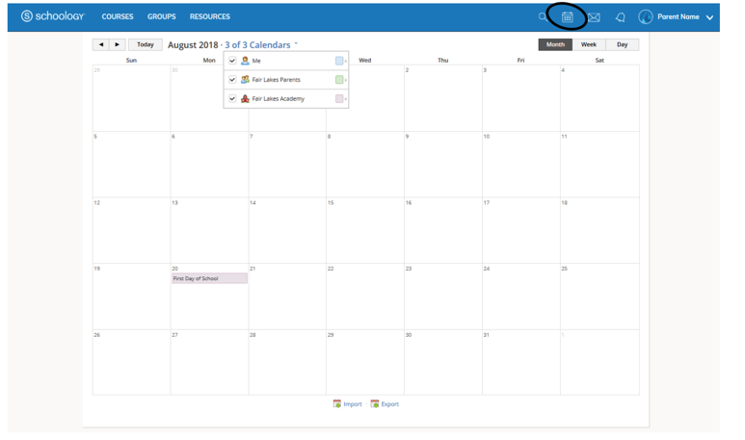
Updates
- Updates and information that the teacher has made about each course/subject can be found in the activity summary in the middle of the home page.

Clever
- Clever is an app that gives students access to programs that they use on their iPad daily.
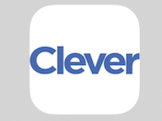
- When students click on the app, it will open up a log in page.
- Click on “Log in with LDAP.”
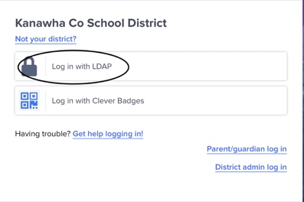
- Your child’s username and password is their 3900 (WVEIS) number.
- Type in your child’s username and password and click log in.
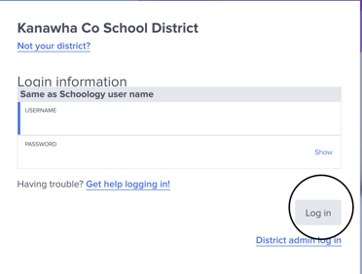
- When you log in, you will see the different programs that we use on a daily basis, such as ST Math.
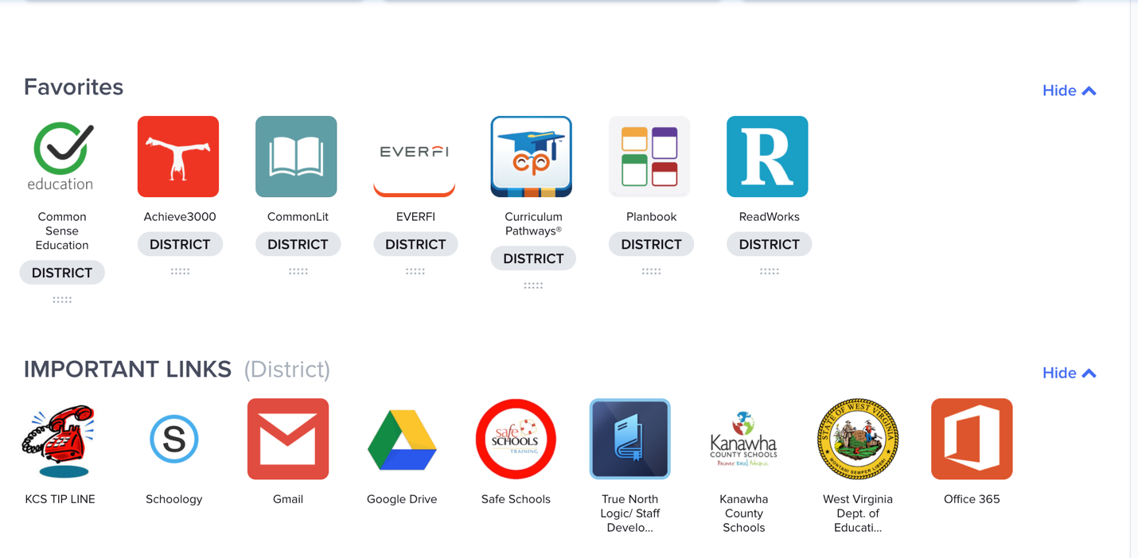
- Clever allows students to click on programs and use them without having to log in every time they want to use them.

